1. Current PMS drop down not coming (Not Fixed )

## as per new logic we have set it current visit only

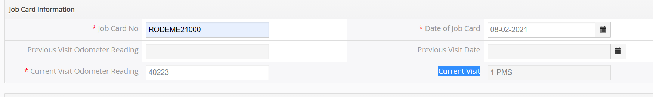

1. Current visit Odometer reading should be 6 character (999999km) and should not except km more than the Service Package End Date.(FIXED- Pop Up is appearing “Current Odometer can not greater than 999999”)

##DONE

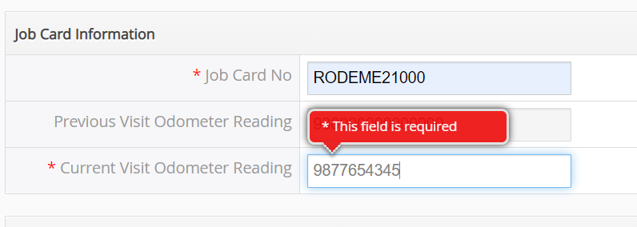

Labour field is Auto selected dealer should select**(NOT FIXED).** ## as our previous confirmation we have set it mandatory to fill up the labour value as by default as per previous request



1. Before saving the service request a pop should come

**“Ensure that the selected Parts & Labour and unit value information is entered correctly as per the Tax invoice”** ##DONE (Fixed)

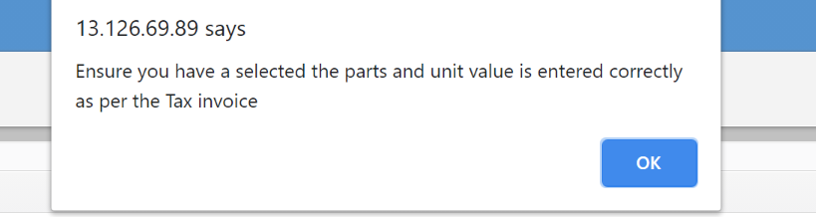

1. Part No and HSN / SAC code should be mandatorily filled by Franchise if the related part or labor is selected. Portal should not allow to save the service request.

**In Pop UP HSN & SAC Code should be capital.**##DONE  **(FIXED)**

**Please fill HSN & SAC Code.**

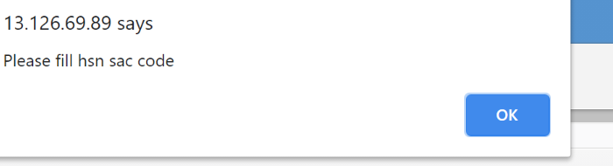

Taxable amount to be showed after Per Unit / Qty . ## where we need to put GST% THEN ?(Not Fixed)

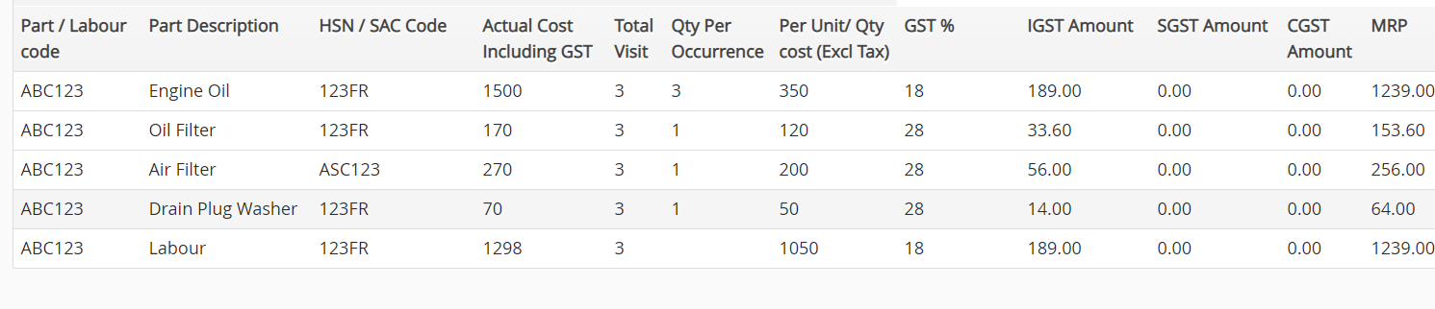

Generated 1 Sr automatically 3 claims generated ##Did not get this issue.



Field name Claim no to be changed as **Service Request No**. ##DONE (Fixed)



1. Payment details cannot be uploaded in portal in Admin login.

Window should be visible in both Assurant (Editable)and Dealer Login (Non-Editable) ##DONE—(payment section is still editable in dealer side-Not Fixed)

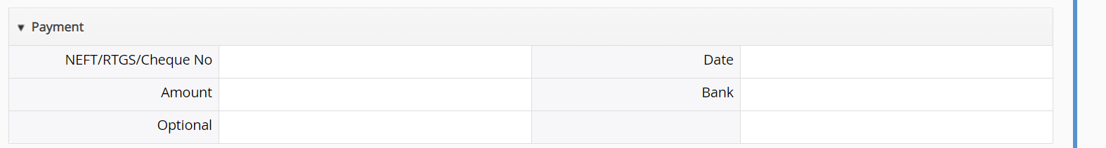

QA Feedback(Date-20/02/2021)

**1.Grand Total Final Price is coming wrong while editing from Assurant login and admin login.(Bug)**

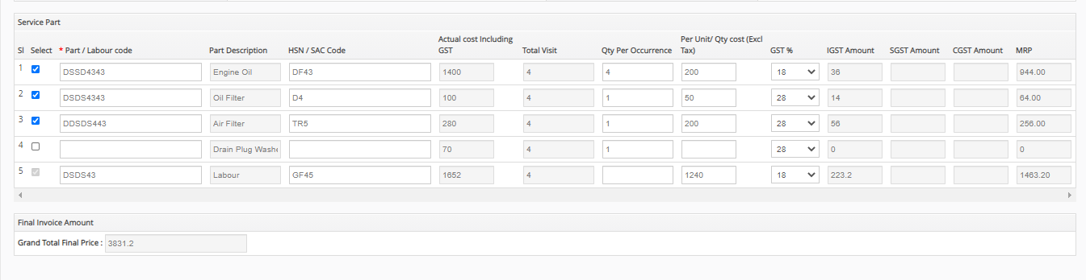

2.incorrect Values are showing in the Total amount (Bug)

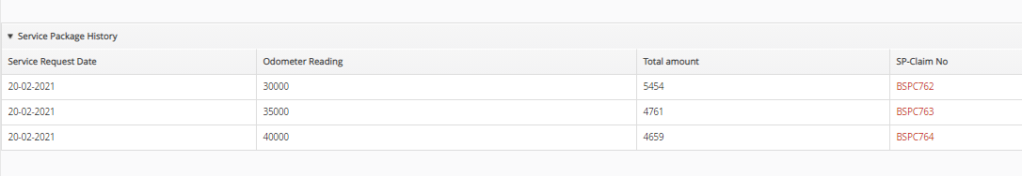

3.Sequence of the validation message is showing wrong(When user is entering value greater than previous odometer reading at that time pop up should show )

4.We can rename this field name to “Service request number”(Suggestion)

